Project Requirements Specification
Assets Management System
Author: Selena Shen
Last Updated: 02/26/14

Executive Summary
This document specifies the requirements of Augmentum internal Assets Management System. This is an initial system requirement collect from Augmentum function support team. It is used for developer team to generate functional specification, and for QA team to write test plan.
Document History
Date | Author | Summary of Change | Note
2011/12/26 | Billy He | Initial version.
2011/12/30 | Berton Wu | Add more attributions of assets
2012/01/04 | Billy He | Update according to comments from IT and Finance
2012/01/05 | Alec Chen | Update functions of different roles
2013/07/05 | Selena Shen | Update functions and add new functions
2013/12/04 | Selena Shen | Update shared customer flag
2014/02/24 | Selena Shen | Update dashboard and add customer group
Table of Contents

Table of Contents 3
Table of Contents 3
Table of Contents 3
Table of Contents 3
Table of Contents 3
Table of Contents 3
Table of Contents 3
Table of Contents 3
Table of Contents 3
Table of Contents 3
Table of Contents 3
Table of Contents 3
Table of Contents 3
Table of Contents 3
Table of Contents 3
Table of Contents 3
Table of Contents 3
Table of Contents 3
Table of Contents 3
Table of Contents 3
Table of Contents 3
1 Project Deliverables 5
2 Schedule （v1.0 no need do this function） 6
3 Project Requirements 7
User Type 7
Assets Assignment Workflow 8
Assets Management 9
Assets Creation 11
Assets Info update 12
Confirm Process 13
Process of customer assets 14
Authentication/Authorization 14
Dash Board 14
Search 20
Asset Operation 20
Customized Column 22
Other functions 23
4 Prerequisite Tools (minor version is flexible) 24
5 Required Design Choices (minor version is flexible) 25
6 New Feature (Need Confirm) 26

Project Deliverables
The project is considered complete when the following deliverables have been fulfilled.

- Project Plan
- Functional Specification
  - Follows the FunctionalSpecTemplate.doc
  - Synchronized with code
- Code Complete
  - Source Code
  - Release Build
  - Release Notes
- Unit Test
  - Unit Test Code
  - Automated Test Scripts
  - Execution Report
- Functional Test
  - Test case design
  - Test report
- Feature Complete Checklist
- Bug List

Note: All code must conform to the Java Coding Convention.

Schedule （v1.0 no need do this function）
The project will be developed by using Scrum model. Each scrum iteration will be 2 weeks. The first day of each iteration is the planning day, and the last day will be demo and retrospective day. There will be daily scrum meeting every morning. All the tasks, estimations will be defined on the planning day, and inputted into Trac system. Every team member must follow the estimation from planning meeting, and update progress every day before leaving company.

Project Requirements

User Type
There are six roles of users in the system:
Employee
- View assets statistics of my assets in dashboard (if he/she has customer assets, he/she also can view assets statistics of customer assets in dashboard
- View the assets that he/she owns
- Take over the assets which belongs to his/her customer, and the group of this customer is in a shared process group
- Return assets back to customer, if the customer is a shared customer
- Export my assets via excel

Special Role
- Manager can assign a special role to employee, let user do the same work as a manager in a customer project, no matter customer is a shared customer or not.
- View transfer log of one asset

Manager
- Confirmed the assets are received
- Return the assets to IT/Customer
- Assign/Reassign employee assets who is in his/her project
- View the assets that belongs to his/her customer
- Maintain all info of assets ownered by the customers when his/her is the project manager of these customers
- Define his/hers own asset property for one customer and one type
- View assets statistics of customer assets in dashboard, if one of his/her customer is in a shared group, he/she can view other customers in group
- Export customer assets
- View assets transfer logs
- Assign employees as a special manager

IT
- Confirm newly coming assets
- Assign assets to managers and ask for confirmation
- Confirm the assets are returned
- Maintain all assets information, including create assets
- Upload the inventory file (.csv format) for audit
- Import assets from file (excel)
- Process assets audit
- View assets transfer logs
- Export all asssets
- Batch update the fixed assets value
- View all assets statistics in dashboard

System Admin
- Assign IT, System Admin role to a user
- View all assets info
- View operation log
- View assets transfer log
- Maintain all locations info
- Maintain shared customer group list
- Maintain scheduler tasks

Assets Assignment Workflow

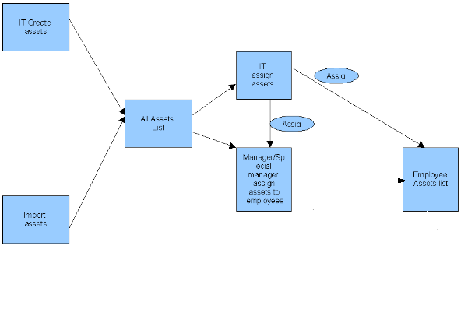
Admin can define three kinds of the process (all the processes can be distinguish between flag):

1). Employee can view all the assets of the customer, if the customer is in a shared process
2). PM/PD can assign the assets of the customer (In this process, employee can't view the asset of the customer).
3). PM/PD can assign the special role (special role has the same authorities with the Manager: the same operation, can self define the property of the assets, can view the dashboard).

Assets Management
Assets Management has seven sub menus, there are
All Assets list
All Fixed Assets list – only IT can view

An asset can be any kind of company property. There is hardware assets like computer, monitor; there is software assets like software license; there is also non-IT assets like air-condition, refrigerator. An asset should contain following info:
- ID: number shown in the list (not uuid), is a readable number
- Name: The brief name of this asset. e.g. ViewSonic LCD.
- Type: The type of this asset. e.g. Hardware, Software.
- Bar-code: The Bar code is filled by IT
- Check-in date: The date time when the assets checked in to company
- PO_No: the PO number of the assets (used to refer to the purchase request). When ownership is Augmentum, PO_No must be filled.（Not do validation for this）
- Used by: The customer where the asset belong to. It will be Augmentum if not for a specific customer.
- Project: The project where the asset belong to.
- Ownership: Augmentum or customer name
- Augmentum Entity: Auto generated from PO number, e.g. 鹏智上海，群硕上海，群硕扬州，群硕武汉
- Fixed Assets (Y/N): IT Used Only
- Site: Augment site, e.g: Augmentum ShangHai, Augmentum WuHan, Augmentum YangZhou
- Location: The project room where the asset locates. e.g. 17206
- User: The people who is responsible for the asset.
- Status: available, borrowed (onsite), broken, write off, returned, idle,in use
- Memo: The detail info or memo of the asset.
- Check-out date: The date time when the assets is checked out from company
- Photo: The photo of asset
- Vendor: Who responsible for repair
- Series Number: An ID which can help to identify an asset
- Manufacturer: The brand of the assets
- Warranty: the end day of the warranty
- Keeper: The keeper of asset.
When IT create asset, if he/she assign this asset to a customer, not choose project, so the keeper is all PM of this customer.
When IT create asset, if he/she assign this asset to a project, so the keeper is the PM of this project.
When IT create asset, if he/she choose customer as “Augmentum China”, so the keeper is “Ping”.

Besides the basic info for all assets, each assets type has its own specific info:
Machine
- Subtype: The subtype of machine, e.g Desktop, Laptop
- Specification: Hardware spec, e.g. Intel Dual Core 2.0GHz, 2G DDR3 RAM.
- Additional Configuration: e.g. 2G additional memory
- Mac address
Monitor
- Size: e.g. 24”
- Specification:
Device:
- Device Subtype:e.g DVD Player
- Specification:
Software
- Version
- License key
- Additional info (URL/login account, subscription number) and has a flag to judge whether this information is visible for manager and employee

Others Assets
- Specification: Projector

Employee/Leader can only view the assets that he/she owns.
Manager/Special Role can view the assets under his/her customer.
IT/System admin can view all the assets.

All the fields of assets list page are sortable and searchable. Pagination should be supported.

Assets Creation
Only IT is allowed to create assets. The creation form is like below. The fields behind grew line will be changed according to the assets type.
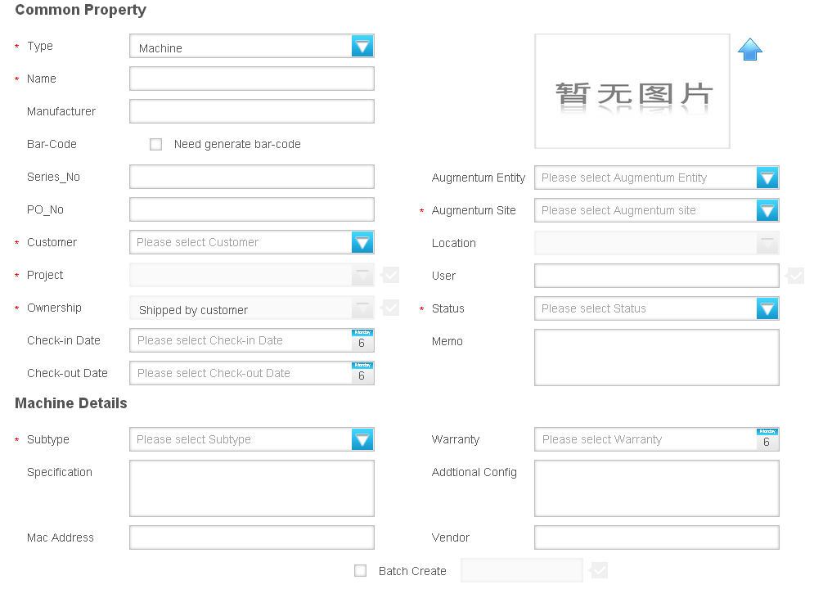
Several notes here:
- Customer and project are associated.(1*n), customer and project can be get from IAP by using web service
- Augmentum site and location are associated.(1*n)
- The user no need belongs to the project.
- While PO is filled in, Augmentum Entity will be generated automatically.(it will be implemented later)
- Check-in time can be filled or leave empty. If leaving empty, check-in time will be saved bu using asset record created time.
- If IT creates the assets, he/she can leave the customer/project/user to be empty. The asset can be assigned later.
- For softeware, removed max using number, so need IT to calculate the count when creating asset.

Assets Info update
- Manager can update the user of the assets within his/her own project. The user must belong to this project.
- IT can update any info of the assets. Such as customer, project, Augmentum site, location, bar-code
- Fixed Assets (Y/N) is only visible by IT. The default value is N. IT can single or batch update it to Y.
- When the user of an asset is rotated out from this project. User will be set to empty, status is idle, and a notice will be sent to this Manager. (Now no need do this)
- Manager can defined properties for one asset type of one customer. The creation form is like below. Defined properties can be added to asset edit form.
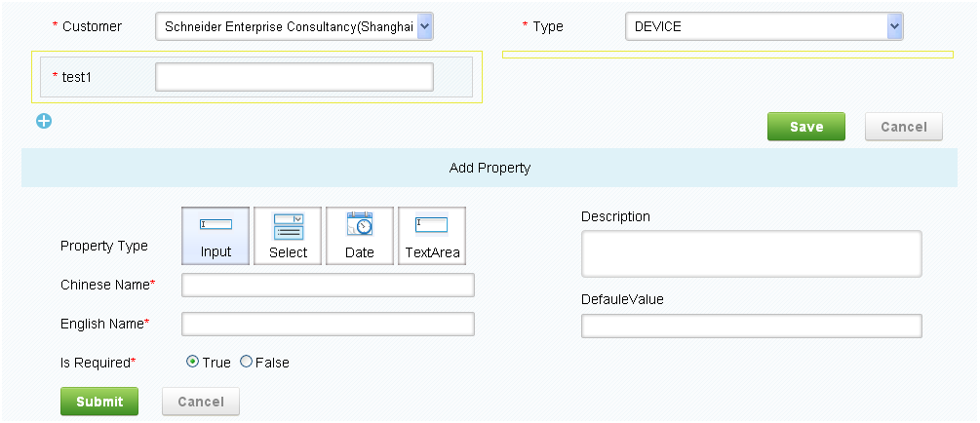

Confirm Process
Assets Assignment Confirm
When IT filled assets, he can leave the customer/project/user as empty and assign those info later. After IT assigns customer/project/user info to an asset, the manager of the project will receive a notice that requires his/her confirm. When manager login the system, the confirm request record will be displayed on dashboard page. Manager should confirm the receipt of this asset. When IT assign assets in “Assets List” page, he/she can choose customer, project and user, but project and user can be empty. User can be chosen by all users, not project users.

Assets Return Confirm
Manager can return the assets to IT. He/she can select the asset from system, and click return button. Then the status of this asset is “Returned”.

Newly Coming Assets Confirm
When PMS has completed a purchase order, PMS will send a message to AMS, AMS will get this message and analysis, displaying in main page - > newly Coming Assets. IT can view this part and click the asset name to complete asset information.

Process of customer assets
- Employees take over assets by themselves
If the customer is a shared process group, then all employees under this customer can view all customer assets in project assets list, and also can take over assets, no need manager to confirm. If this customer has other shared customer in the same group, so all employees under this customer also can view customer assets under same group.
- Employee can return assets to project
If the customer is a shared process group, then all employees under this customer can return assets to project.
- Manager or special role user can assign assets to one employee
Manager can assign a special role to employees who under his/hers project. If the employee has this role, he/she can help manager do same work as manager. Manager or special role user can assign assets to one employee.
- Manager or special role can return asset to IT/Customer
Manager or special role user can return assets to IT/customer.

Authentication/Authorization
- There is a login page, and users can only login with correct username and password (Login function will use CAS)
- Employee's, Leader's and Manager’s role can be retrieved from IAP
- IT's, System Admin role is set by system admin of this system
- Special manager role can be assigned by manager under same customer
- User should logout after finish using the system.
- 30 minutes time out if the page is idle

Dash Board
After every user logs in, there is a personal dash board page be displayed as the main page.
Employee/ Leader
- List how many assets he/she owns, classified by assets type.
- Having notice if his/hers assets were assigned or assigned out(Now no need do this)
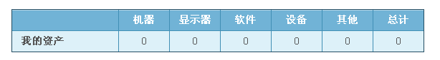
Manager/Special Role
- List how many assets he/she owns, classified by assets type. (Employee role)
- List how many assets belong to his/her customer or the customer which is in the same group with him/her , classified by assets type.
- List the assets assignment info that he/she needs to confirm
- List idle assets info that can be returned back to IT
- Having notice about which employee has taken over which asset if his/hers
customer is a shared customer.(Now no need do this)
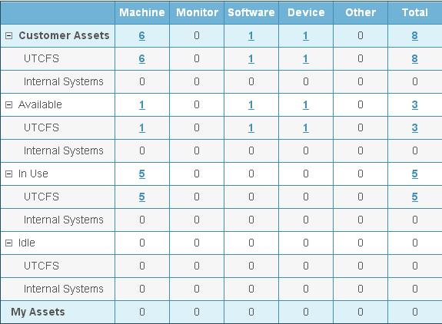

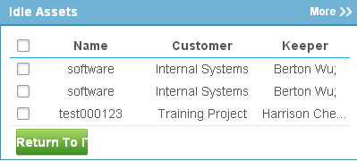
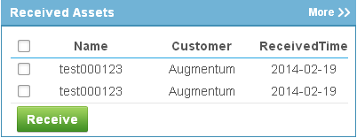

IT
- List how many assets he/she owns, classified by assets type. (Employee role)
- List how many assets in the system, classified by assets type and status.
- List the assets returned info that he/she needs to confirm. (For this part, the owner of these assets is “Augmentum” )
- List the assets whose warranty time will be expired. (Before warranty time 30 days ago)
- List the newly coming assets (recently purchase items from PMS system) what need to save as assets into the database.
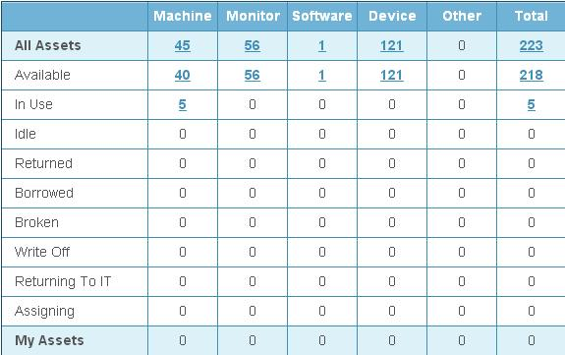
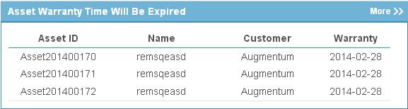
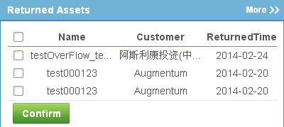
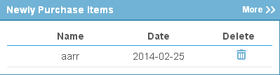

System admin
- List how many assets he/she owns, classified by assets type. (Employee role)
- List how many assets in the system, classified by assets type and status.
- List five records of users which is modifiled recently.(Now no need do this)
- List five records of customers which is modifiled recently.(Now no need do this)
- List five records of scheduler information which is modifiled recently.(Now no need do this)

Search
Filter
Every user will have a search box on the page. It is a full text search that can search all kind of fields of assets. After the user input the keyword, and click search button, system will match the keyword of all the fields (e.g. memo, specification, manufacturer, etc). Note that the search will limit to the records that the user can view.
View (need confirm)
Every user can defined self views, in his/hers views, he/she can select a property, match condition, match values and so on. In his/hers list page, he/she can use view to filter search results.

Asset Operation
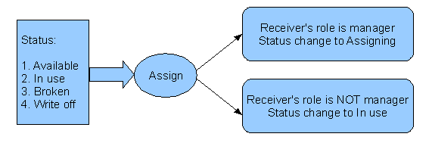
- IT Assign Assets:
- Manager / Special Role Assign Assets

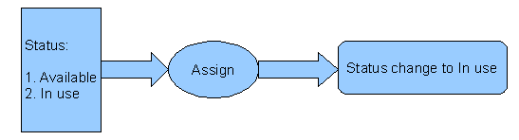
- Take over Assets
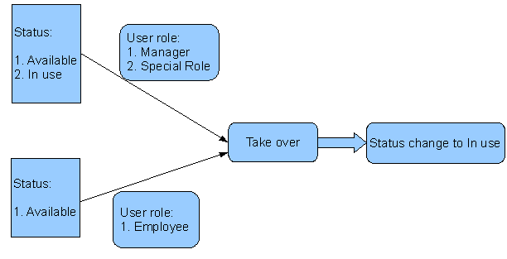
- Manager/Special Manager Return To Customer

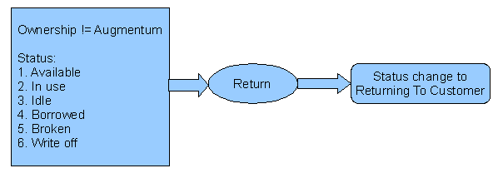
- Manager / Special Role Return To IT

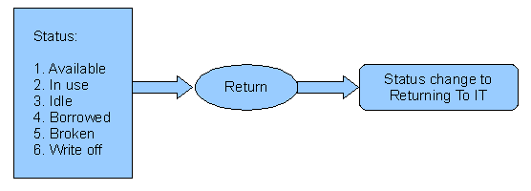
- Manager / Special Role / Employee Return To Project

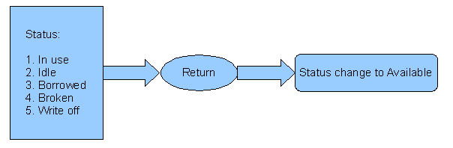

Customized Column
Every user will choose he/she concerned column and select them in nine grids in list page. Next time he/she can only see customized column in list page. And he/she also can move the sequence of customized column, and the result will affect the sequence of data list columns.

Other functions
- System should support both Chinese/English. Also can be extended to more languages later
- CVS inventory records check.
- Can upload photo for one asset. Attachment file can be bmp, jpg, png, gif, eml, msg, mht. Attachment size should be less than 1M.
- There is a TODO list for IT to shows the request that need to be processed
- Mail function: A mail will be sent to asset user, manager, IT when an asset is updated.(Don't do)
- Each operation will be logged in database, and system admin can see the operation log.
- There is no physical delete in the system. All deletion is logical delete.
- There should be JS validation for field filling in. And in backend, it will use JSR303 do validation, if got exception, it will log the exception and message.
9. Customer share flag has four status:
a. share between customers, if customers in a same shared group
b. share between projects in one customer. (Users belongs to this customer can see all customer assets), if only this one customer in a shared group
c. no share(only manager/special manager can view customer assets)

Prerequisite Tools (minor version is flexible)
JDK 1.7
Log4J 1.2.16
JUnit 4.8.2
Tomcat 7.0
MySQL 5.5

Required Design Choices (minor version is flexible)
Logging
All logging of system information will be done with Log4J.

Unit Tests
All unit tests will be completed with JUnit test framework.

Internationalization (I18N)
String literals that can be localized later (visible labels, error messages, informational messages, etc.) must be in Java resource bundle.

Spring MVC
The presentation layer will be developed using Spring MVC.

Spring Framework 3.0.2
Use IOC/AOP to complete the business logic

Hibernate 3.5.3
Implement persistent layer with ORM.

New Feature (Need Confirm)
- Employee can report to repair
Employee can report a repair request when his/hers asset has problem
- Employee can add comment for assets
Employee can comment assets when he/she is the user of these assets and this comments can be sent to PMS system.
- Reports
Asset assignment report
Asset repair report
Return back report
Idle assets report
- Assets classified management
System admin can maintain assets classified management
- Extended Assets Attributions management
Manager can add extended assets attributions for one customer
- Manger can assign role “leader” to an employee
Manger can assign project role “leader” to an employee, when the employee has this role, he/she can assign assets to other employees.
- Assets depreciation management
IT can process this operation for assets.

